100 Days of Deep Learning | Course Announcement

https://www.youtube.com/watch?v=2dH_qjc9mFg&list=P…_RmvYuZauWaPlRTC54KxSNLtNn&index=1&t=237s&pp=iAQB
wdw

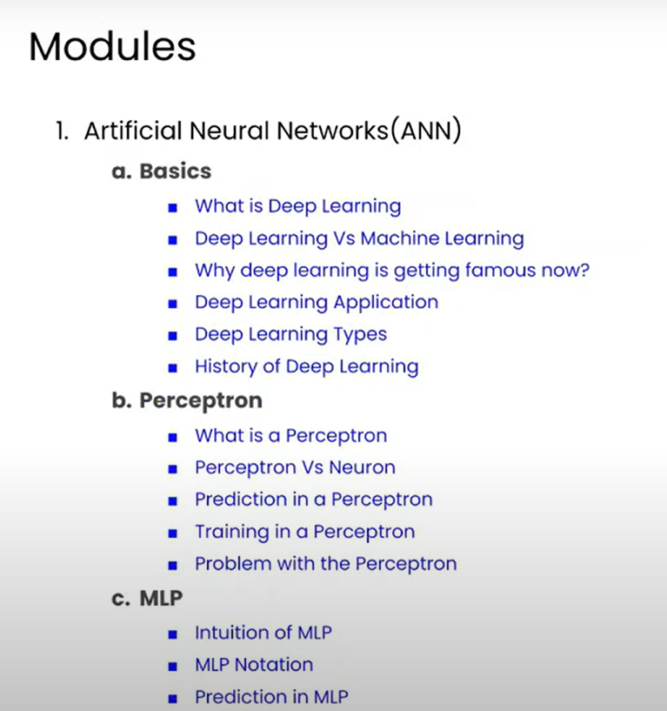
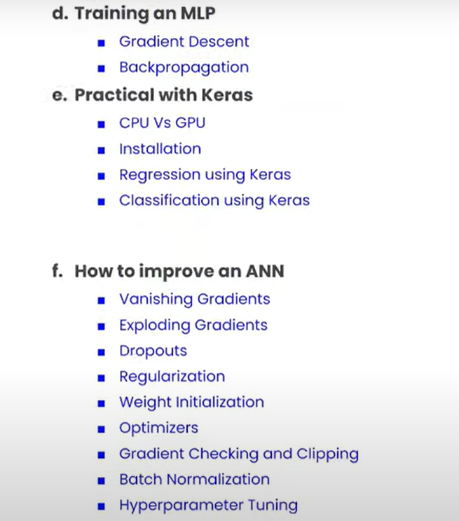
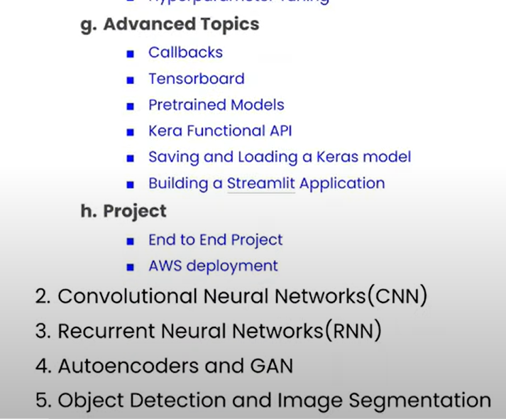

What is Deep Learning? Deep Learning Vs Machine Learning | Complete Deep Learning Course

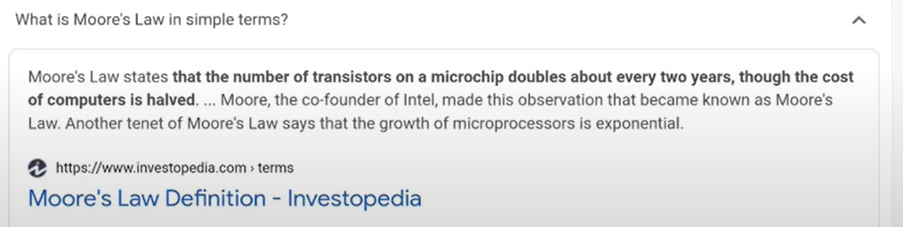
https://www.youtube.com/watch?v=fHF22Wxuyw4&list=PLKnIA16_RmvYuZauWaPlRTC54KxSNLtNn&index=2&pp=iAQB


Types of Neural Networks | History of Deep Learning | Applications of Deep Learning
https://www.youtube.com/watch?v=fne_UE7hDn0&list=PLKnIA16_RmvYuZauWaPlRTC54KxSNLtNn&index=3&pp=iAQB
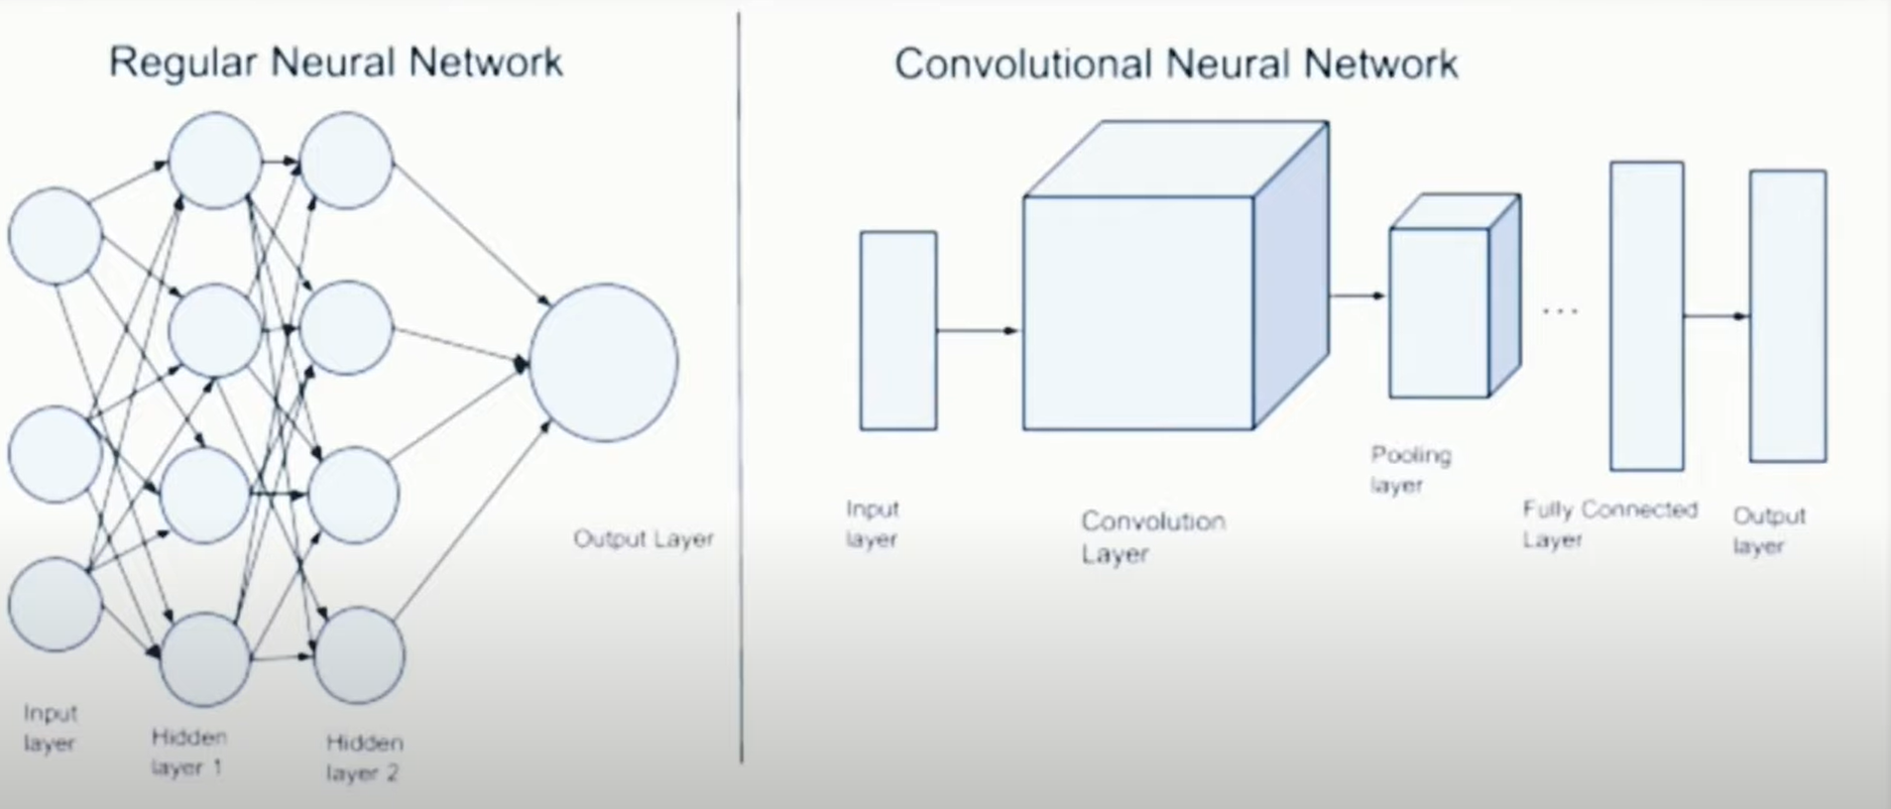
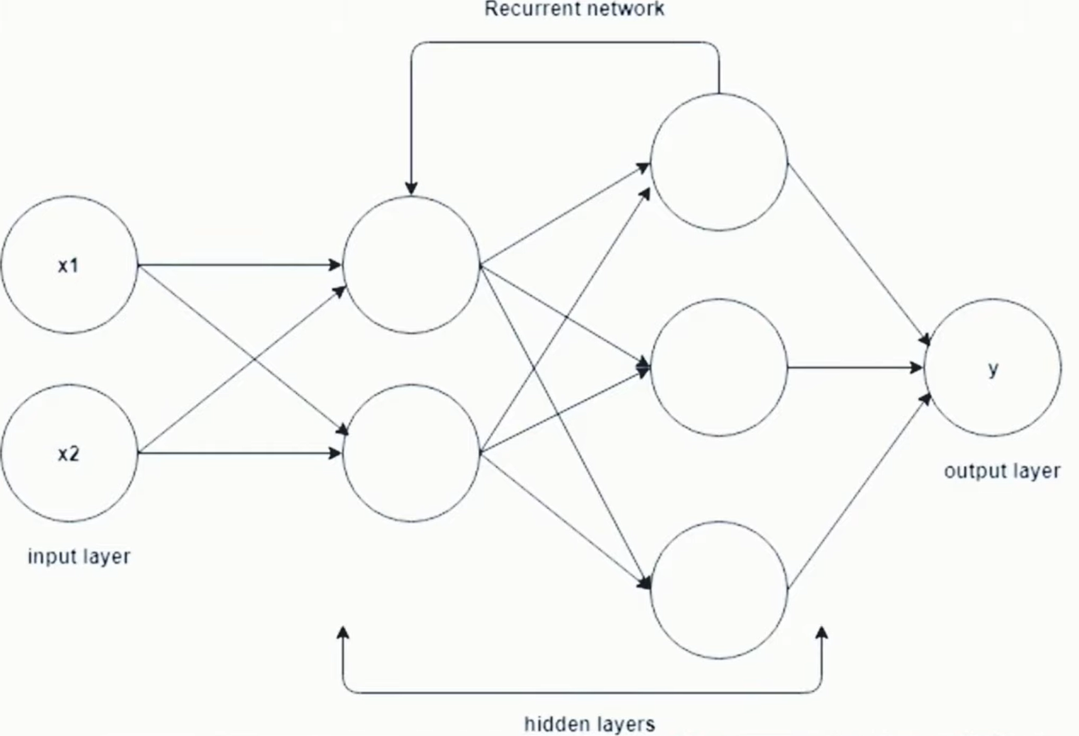

1. About ANN - https://en.wikipedia.org/wiki/Artific... 2. About CNN - https://en.wikipedia.org/wiki/Convolu... 3. yann le cunn - https://en.wikipedia.org/wiki/Yann_LeCun 4. About RNN - https://en.wikipedia.org/wiki/Recurre... 5. About Autoencoders - https://en.wikipedia.org/wiki/Autoenc... 6. About GAN - https://machinelearningmastery.com/wh... 7. Unsupervised Pre-training - https://www.jmlr.org/papers/volume11/... 8. ImageNET - https://www.image-net.org/ 9. Alphago - • AlphaGo - The Movie | Full award-winn... 10. Image Colorization - https://pyimagesearch.com/2019/02/25/... 11. Audio gen in mute video - • AI Synthesized Sound: Rain 12. Image Caption gen - https://www.analyticsvidhya.com/blog/... 13. Pixel Restoration - https://www.analyticsvidhya.com/blog/... 14. This person does not exist - https://thispersondoesnotexist.com/ 15. AI generates story - • Sunspring | A Sci-Fi Short Film Starr... 15. Deep Dream - • A.I. ART TUTORIAL - DEEP DREAM Gen...

What is a Perceptron? Perceptron Vs Neuron | Perceptron Geometric Intuition
https://www.youtube.com/watch?v=X7iIKPoZ0Sw&list=PLKnIA16_RmvYuZauWaPlRTC54KxSNLtNn&index=4&pp=iAQB

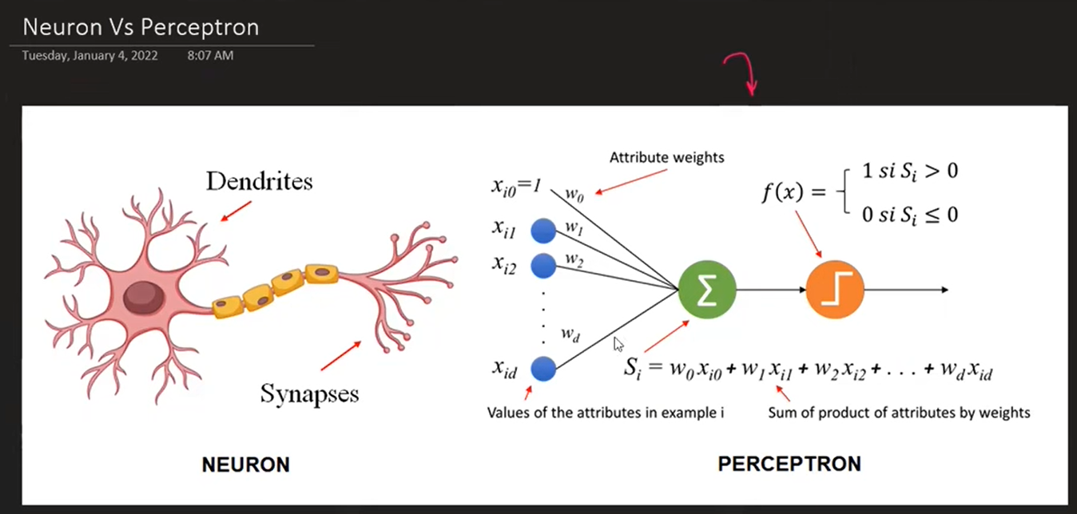
Code: https://github.com/campusx-official/100-days-of-deep-learning/tree/main/day3

Perceptron Trick | How to train a Perceptron | Perceptron Part 2 | Deep Learning Full Course
https://www.youtube.com/watch?v=Lu2bruOHN6g&list=PLKnIA16_RmvYuZauWaPlRTC54KxSNLtNn&index=5&pp=iAQB

Code: https://github.com/campusx-official/100-days-of-deep-learning/tree/main/day4
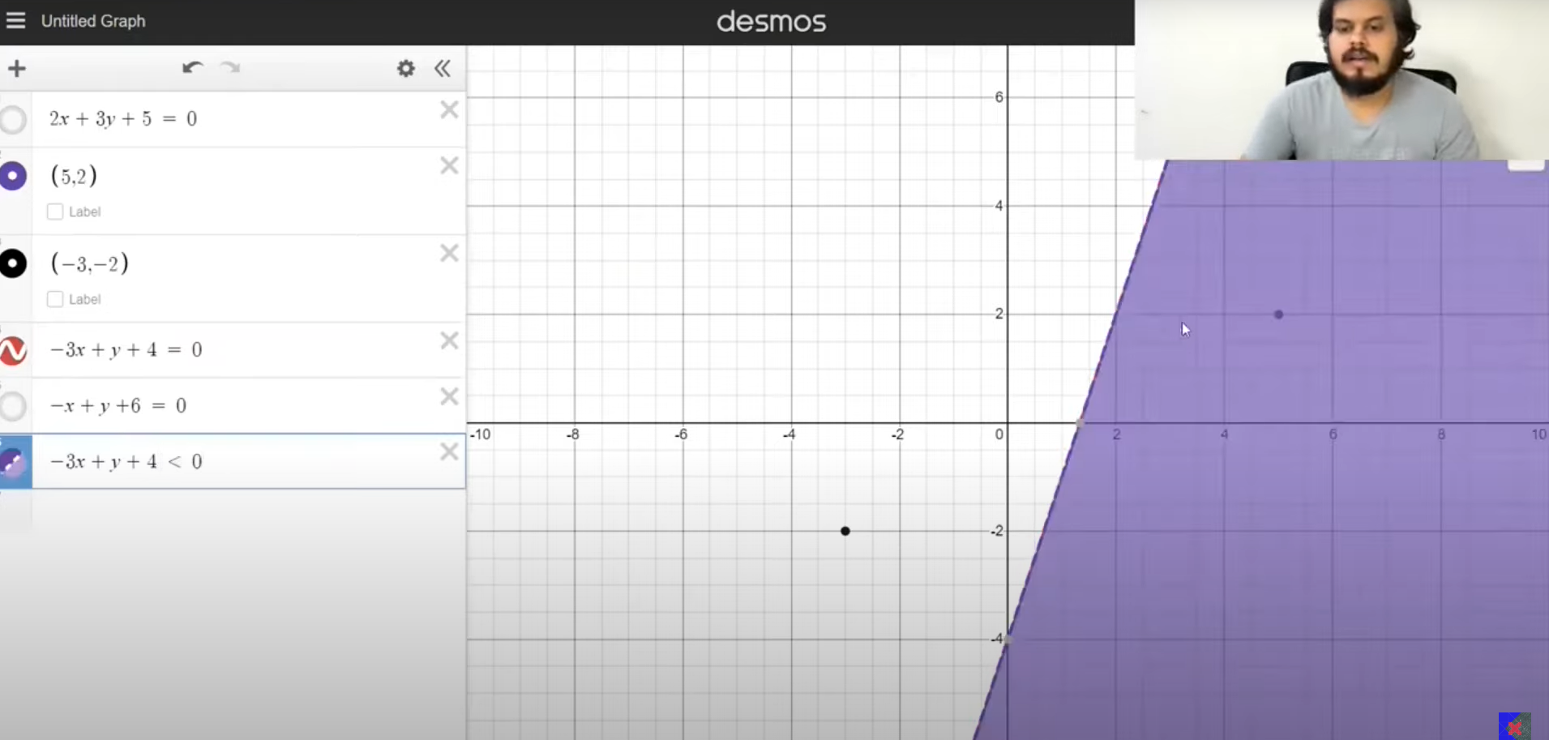

Perceptron Loss Function | Hinge Loss | Binary Cross Entropy | Sigmoid Function
https://www.youtube.com/watch?v=2_gCL5RAkHc&list=PLKnIA16_RmvYuZauWaPlRTC54KxSNLtNn&index=6&pp=iAQB
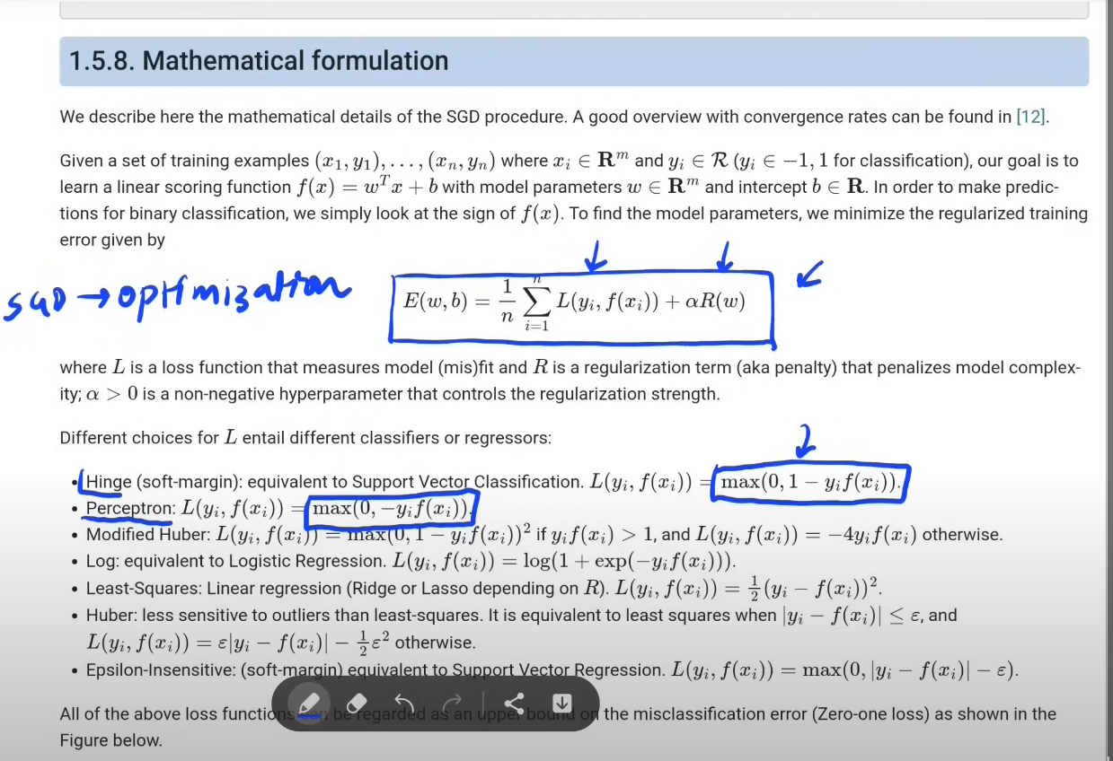
Sklearn: https://scikit-learn.org/stable/modules/sgd.html
Code: https://github.com/campusx-official/100-days-of-deep-learning/tree/main/day5%20-%20Perceptron%20Loss%20Function
Problem with Perceptron
https://colab.research.google.com/drive/1x6detmf4WAUAT2pfdCts-dVrqnz4_gNB?usp=sharing : Code

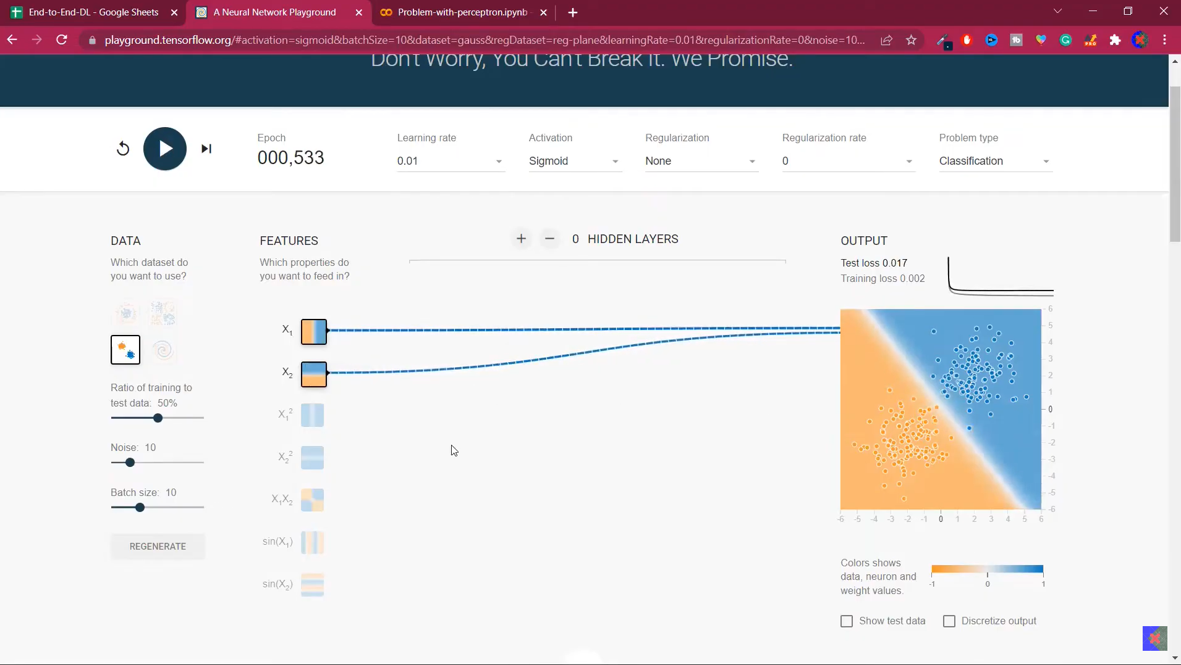
XOR
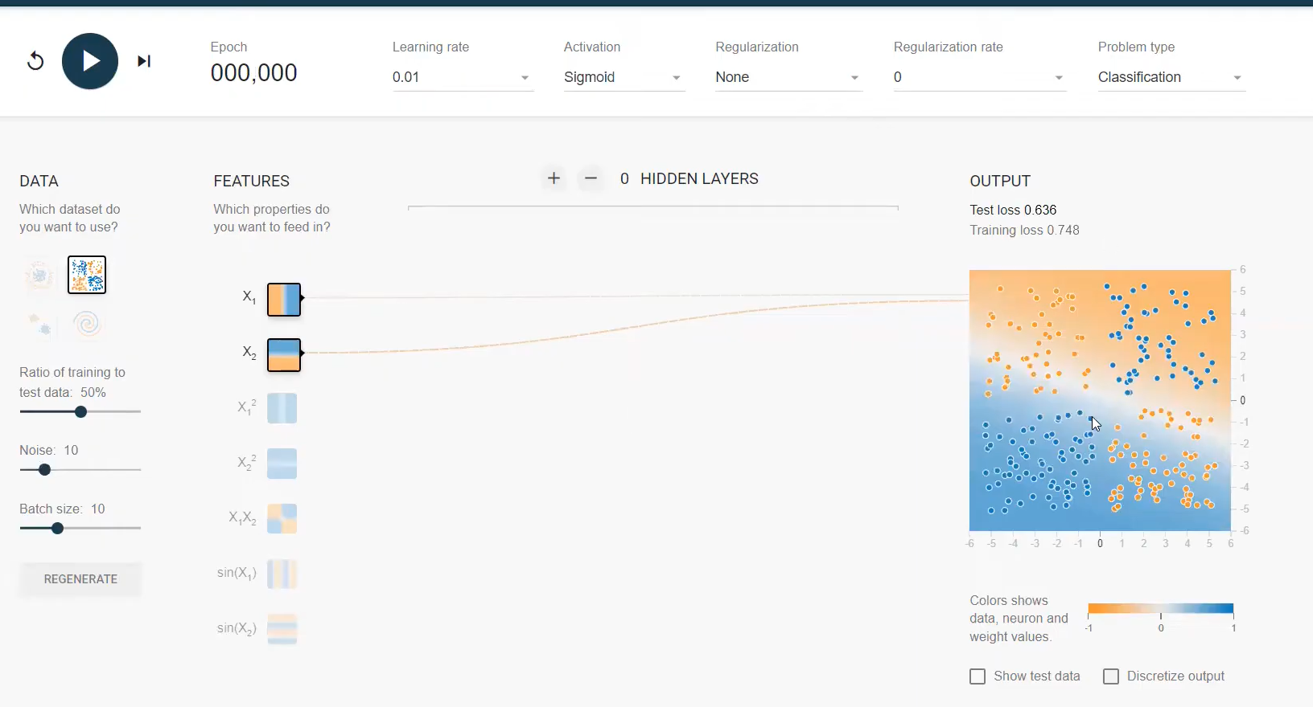
Error is very high in XOR case. Kitna bhi time de do.
https://colab.research.google.com/drive/1x6detmf4WAUAT2pfdCts-dVrqnz4_gNB?usp=sharing
https://playground.tensorflow.org/#activation=tanh&batchSize=10&dataset=circle&regDataset=reg-plane&learningRate=0.03&regularizationRate=0&noise=0&networkShape=4,2&seed=0.25299&showTestData=false&discretize=false&percTrainData=50&x=true&y=true&xTimesY=false&xSquared=false&ySquared=false&cosX=false&sinX=false&cosY=false&sinY=false&collectStats=false&problem=classification&initZero=false&hideText=false

MLP Notation
https://www.youtube.com/watch?v=H0_3SJh4Rqs&list=PLKnIA16_RmvYuZauWaPlRTC54KxSNLtNn&index=8&pp=iAQB

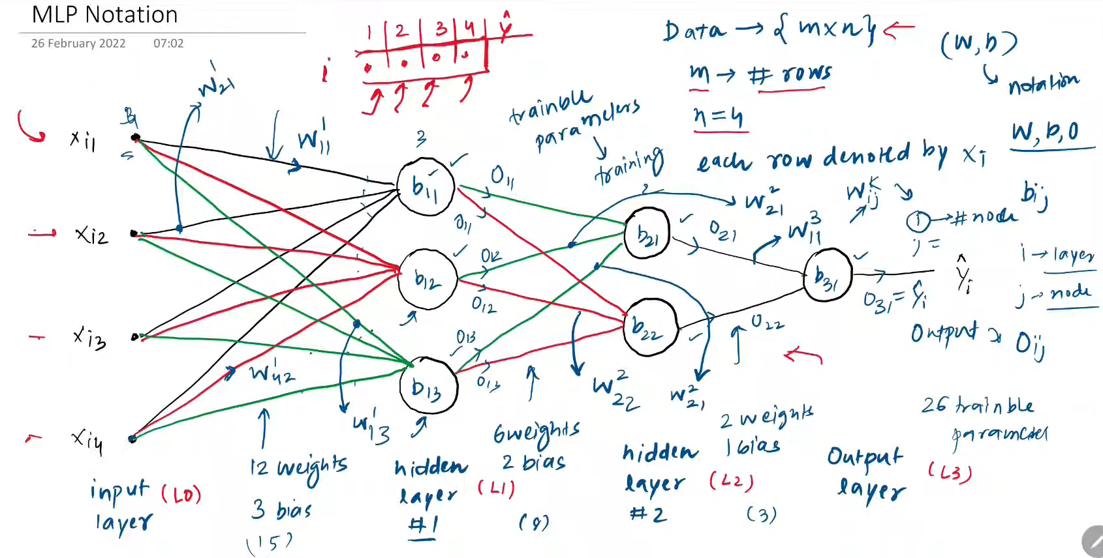

Multi Layer Perceptron | MLP Intuition
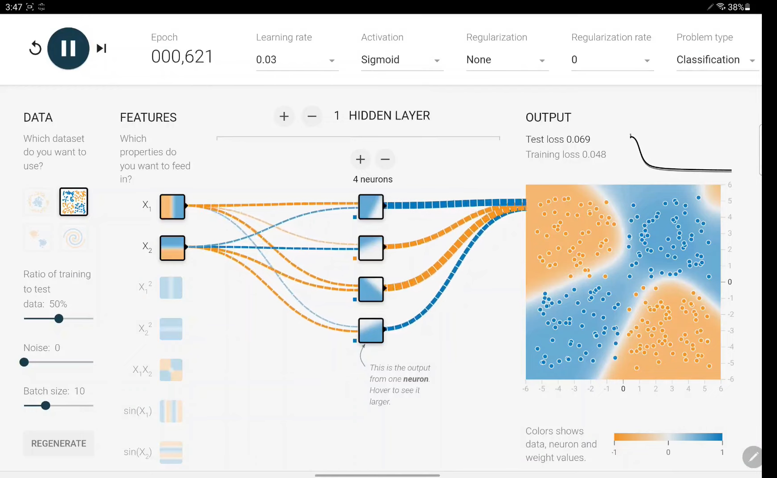
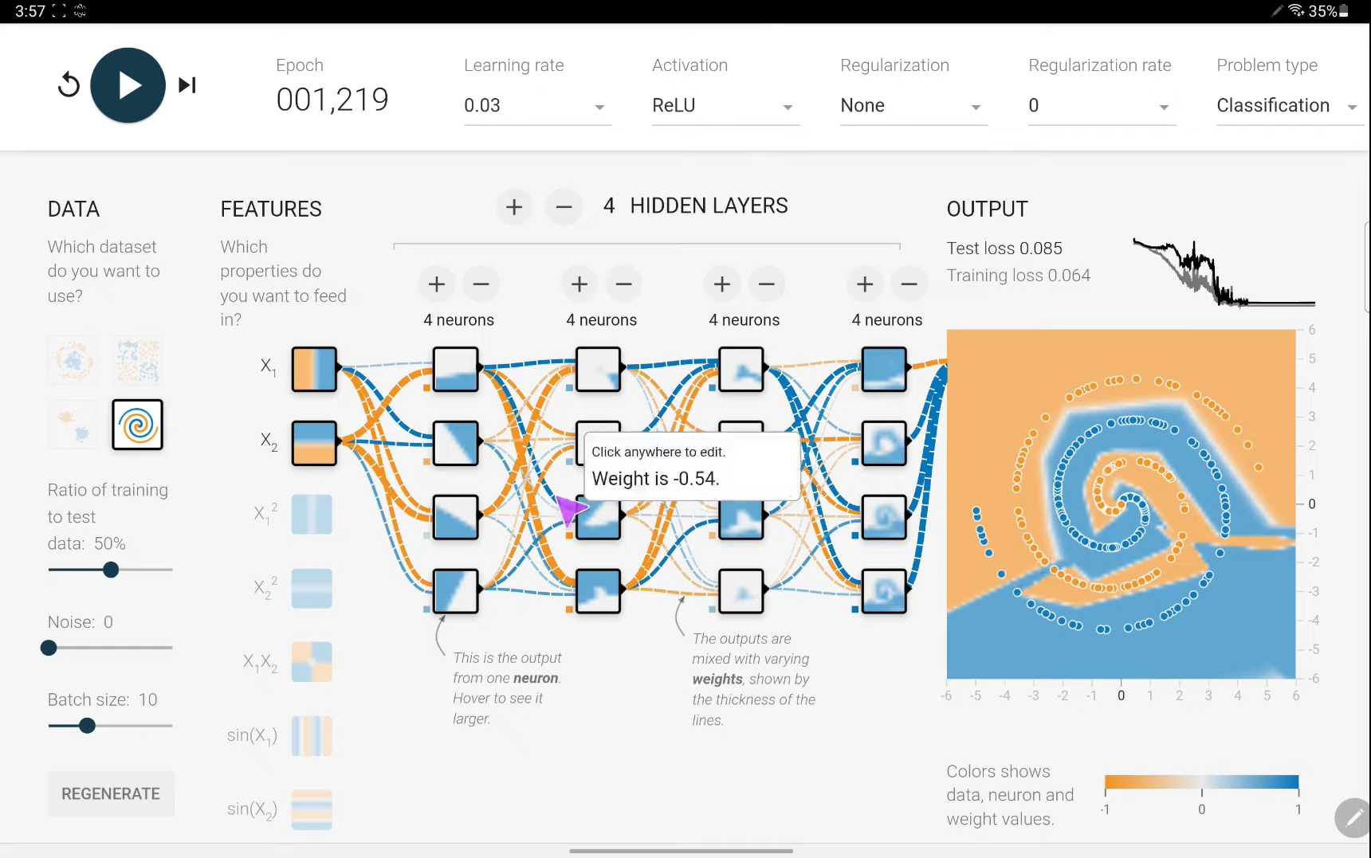

Forward Propagation | How a neural network predicts output?
https://www.youtube.com/watch?v=7MuiScUkboE&list=PLKnIA16_RmvYuZauWaPlRTC54KxSNLtNn&index=10&pp=iAQB

Customer Churn Prediction using ANN | Keras and Tensorflow | Deep Learning Classification
https://www.youtube.com/watch?v=9wmImImmgcI&list=PLKnIA16_RmvYuZauWaPlRTC54KxSNLtNn&index=11&pp=iAQB

Code Practical: https://www.kaggle.com/code/campusx/notebook8ad570467f
This is overfitting case.

Handwritten Digit Classification using ANN | MNIST Dataset
https://www.youtube.com/watch?v=3xPT2Pk0Jds&list=PLKnIA16_RmvYuZauWaPlRTC54KxSNLtNn&index=12&pp=iAQB

Code: https://colab.research.google.com/drive/1SqETl3Zi1EEesdJfEv6_QimB-M-YjKGx?usp=sharing

Graduate Admission Prediction using ANN
https://www.youtube.com/watch?v=RCmiPBiA4qg&list=PLKnIA16_RmvYuZauWaPlRTC54KxSNLtNn&index=13&pp=iAQB

Code: https://www.kaggle.com/code/campusx/gre-admission-prediction

Loss Functions in Deep Learning | Deep Learning | CampusX
https://www.youtube.com/watch?v=gb5nm_3jBIo&list=PLKnIA16_RmvYuZauWaPlRTC54KxSNLtNn&index=14&pp=iAQB

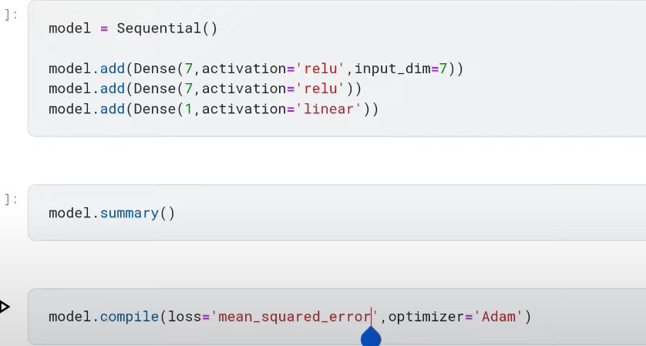
Last me activation fxn linear hoga. Tabhi hum mean_squared_error.

Backpropagation in Deep Learning | Part 1 | The What?

https://www.youtube.com/watch?v=6M1wWQmcUjQ&list=PLKnIA16_RmvYuZauWaPlRTC54KxSNLtNn&index=15&pp=iAQB

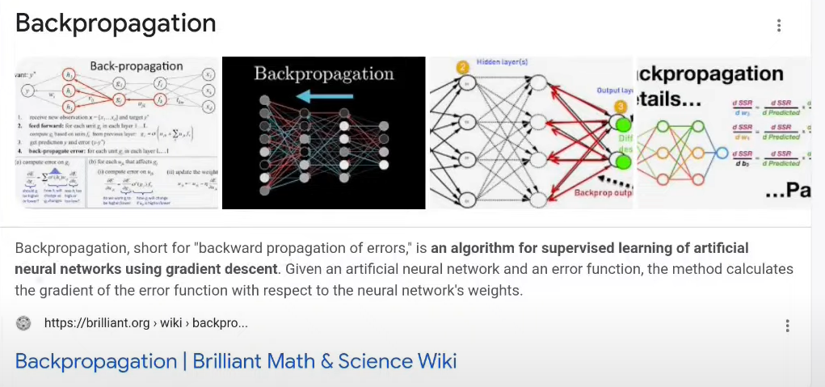

Backpropagation Part 2 | The How | Complete Deep Learning Playlist
https://www.youtube.com/watch?v=ma6hWrU-LaI&list=PLKnIA16_RmvYuZauWaPlRTC54KxSNLtNn&index=16&pp=iAQB

Code used Regression - https://colab.research.google.com/dri...
Classification - https://colab.research.google.com/dri...
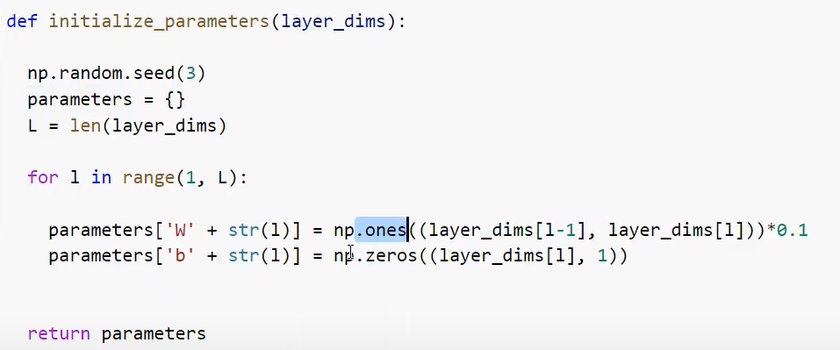
We could use random function instead of ones and zeros function.

Backpropagation Part 3 | The Why | Complete Deep Learning Playlist
https://www.youtube.com/watch?v=6xO-x8y0YSY&list=PLKnIA16_RmvYuZauWaPlRTC54KxSNLtNn&index=17&pp=iAQB

Use this google tool to visualize: https://developers-dot-devsite-v2-prod.appspot.com/machine-learning/crash-course/backprop-scroll

MLP Memoization | Complete Deep Learning Playlist
https://www.youtube.com/watch?v=rW0eeTXas4k&list=PLKnIA16_RmvYuZauWaPlRTC54KxSNLtNn&index=18&pp=iAQB

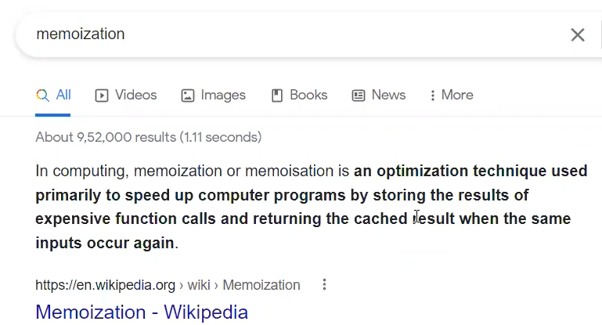

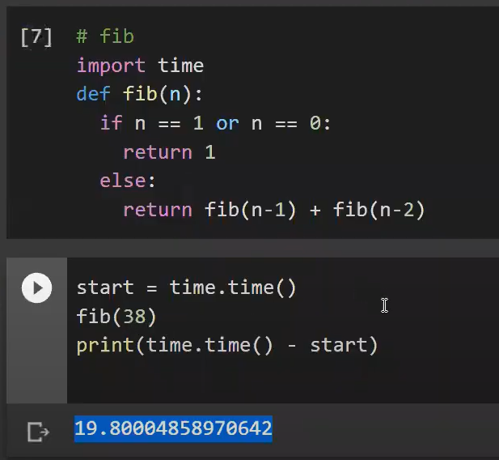
Fibonacci code
Memoized code
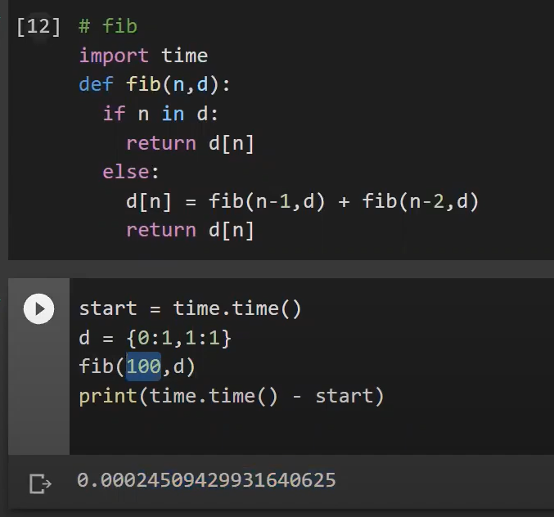

Gradient Descent in Neural Networks | Batch vs Stochastics vs Mini Batch Gradient Descent
https://www.youtube.com/watch?v=7z6yXpYk7sw&list=PLKnIA16_RmvYuZauWaPlRTC54KxSNLtNn&index=19&pp=iAQB

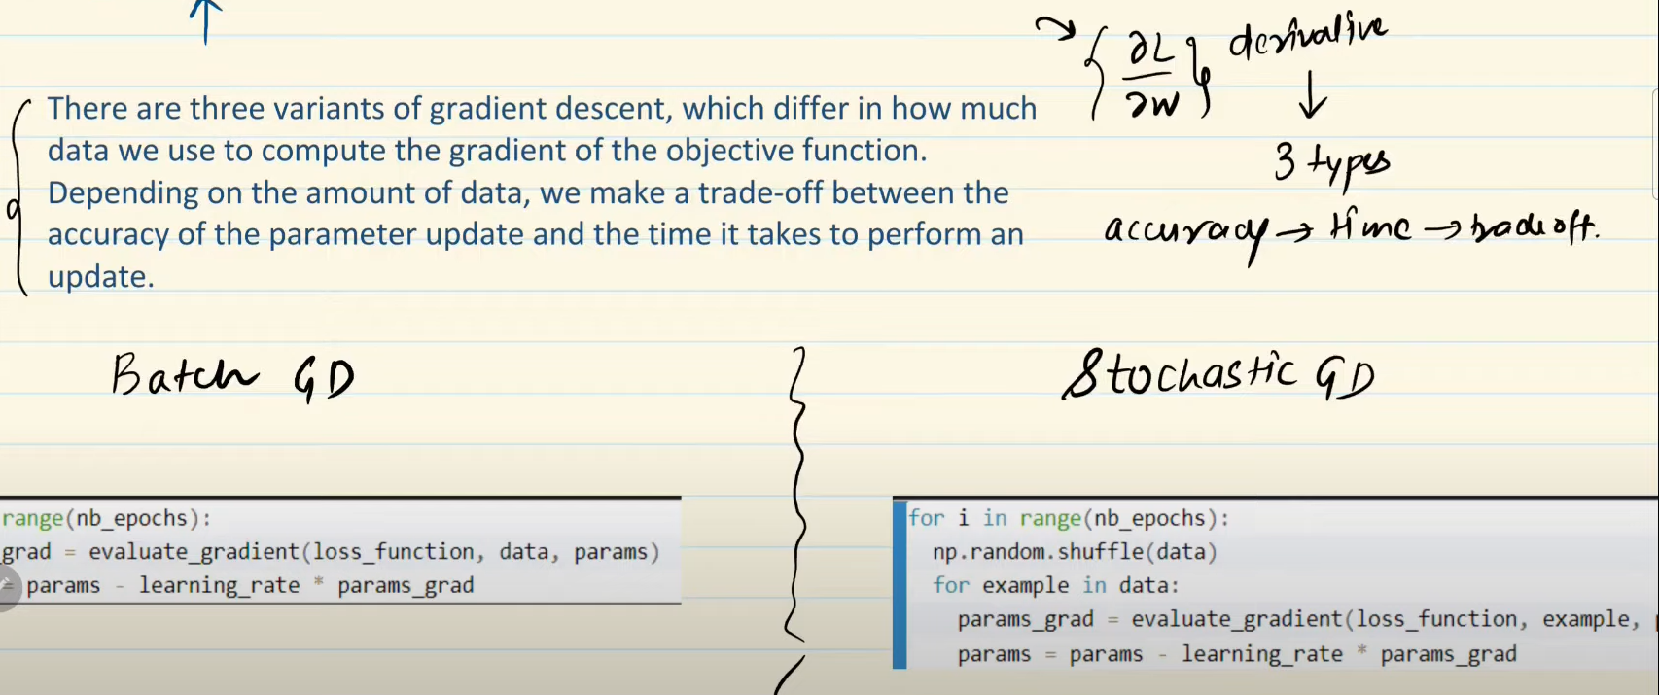
Code: https://colab.research.google.com/drive/131xWdpUiy_f87tN0dRpKaEvOxR9DoiSB?usp=sharing

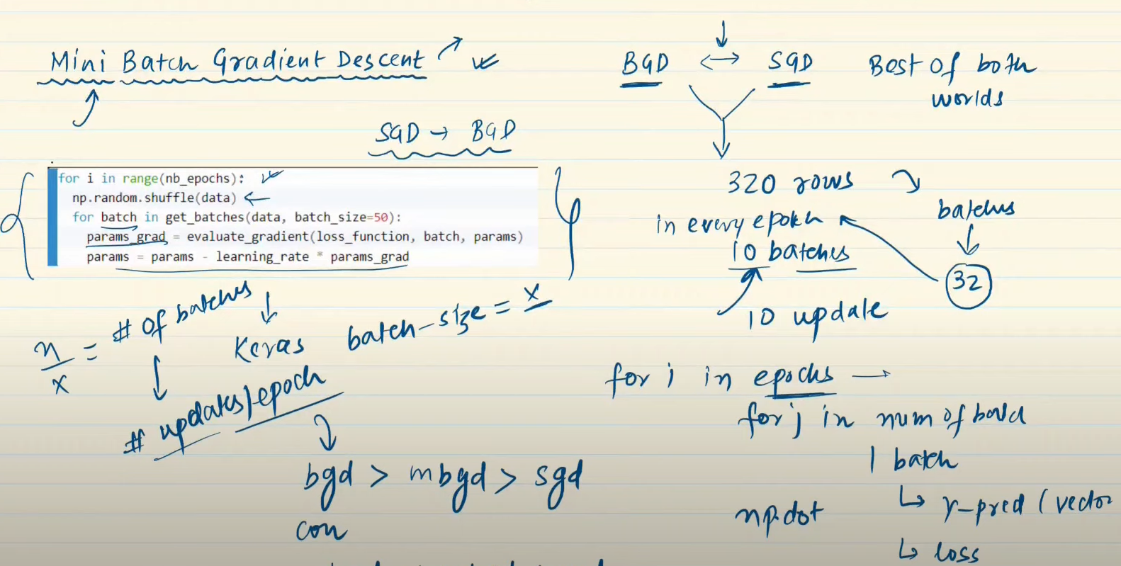

Vanishing Gradient Problem in ANN | Exploding Gradient Problem | Code Example
https://www.youtube.com/watch?v=uCrevbBh0zM&list=PLKnIA16_RmvYuZauWaPlRTC54KxSNLtNn&index=20&pp=iAQB

Code: https://colab.research.google.com/drive/1j1qAWzo6sjNU3f_vkMMijOAuFi1JoV8p?usp=sharing

How to Improve the Performance of a Neural Network

https://www.youtube.com/watch?v=Ue_6n1yT_R8&list=PLKnIA16_RmvYuZauWaPlRTC54KxSNLtNn&index=21&pp=iAQB

Early Stopping In Neural Networks | End to End Deep Learning Course
https://www.youtube.com/watch?v=Ygvskt5HadI&list=PLKnIA16_RmvYuZauWaPlRTC54KxSNLtNn&index=22&pp=iAQB

Code: https://colab.research.google.com/drive/1JG6PCAa5A0-CLOcKhugqU4uyZXWNjtKP?usp=sharing
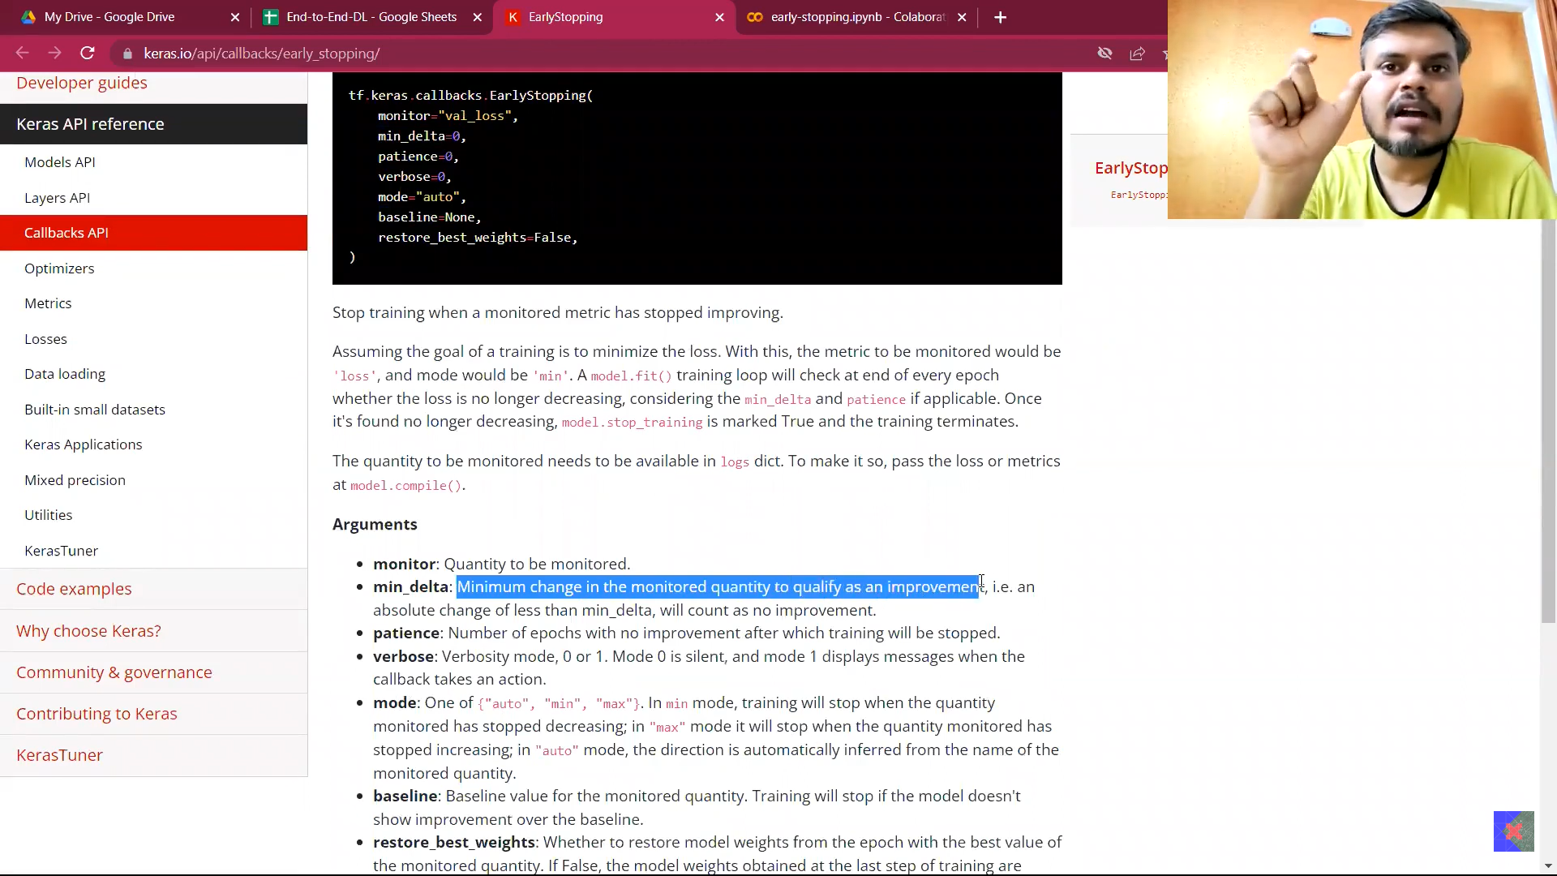
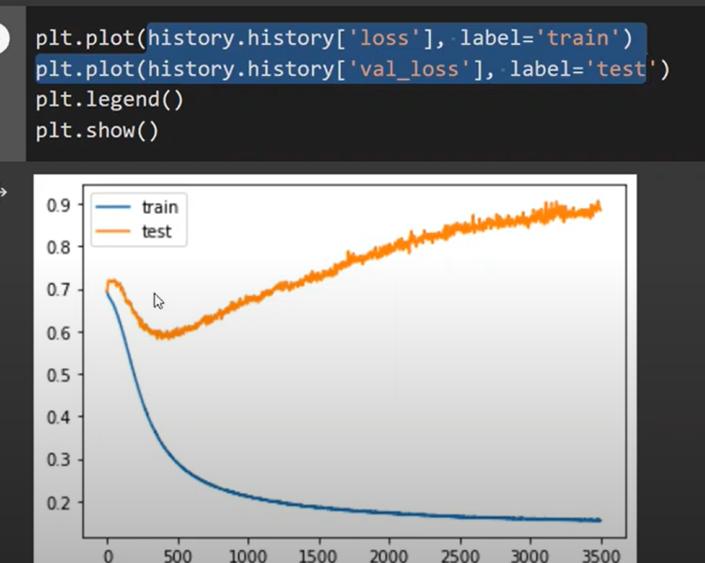
Yha pe 300-350 tak hi training shi tha uske baad loss badhne lga aur overfitting hone lga.

Data Scaling in Neural Network | Feature Scaling in ANN | End to End Deep Learning Course
https://www.youtube.com/watch?v=mzRO0cVppQ0&list=PLKnIA16_RmvYuZauWaPlRTC54KxSNLtNn&index=23&pp=iAQB

Code: https://colab.research.google.com/drive/1lexRUY37fJd6op-WiJicPRB65PwA8YaO?usp=sharing
1. Normalization: It can be used when data does contain outliers. Scikit-Learn provides a transformer called MinMaxScaler for this. It has a feature_range hyperparameter that lets you change the range if, for some reason, you don’t want 0–1 (e.g., neural networks work best with zero-mean inputs, so a range of –1 to 1 is preferable).
2. Standardization: Unlike minmax scaling, standardization does not restrict values to a specific range. However, standardization is much less affected by outliers.
3. Data with a heavy tail: When a feature’s distribution has a heavy tail (i.e., when values far from the mean are not exponentially rare), both min-max scaling and standardization will squash most values into a small range. Models generally don’t like this at all. So before you scale the feature, you should first transform it to shrink the heavy tail, and if possible to make the distribution roughly symmetrical. For example, a common way to do this for positive features with a heavy tail to the right is to replace the feature with its square root (or raise the feature to a power between 0 and 1). If the feature has a really long and heavy tail, such as a power law distribution, then replacing the feature with its logarithm may help. Another approach to handle heavy-tailed features consists in bucketizing the feature. This means chopping its distribution into roughly equal-sized buckets, and replacing each feature value with the index of the bucket it belongs to.
4. Data with multiple peaks: When a feature has a multimodal distribution (i.e., with two or more clear peaks, called modes), it can also be helpful to bucketize it, but this time treating the bucket IDs as categories, rather than as numerical values. This means that the bucket indices must be encoded, for example using a OneHotEncoder (so you usually don’t want to use too many buckets). This approach will allow the model to more easily learn different rules for different ranges of this feature value. Another approach to transforming multimodal distributions is to add a feature for each of the modes (at least the main ones). The similarity measure is typically computed using a radial basis function (RBF)—any function that depends only on the distance between the input value and a fixed point. The most commonly used RBF is the Gaussian RBF, whose output value decays exponentially as the input value moves away from the fixed point. Reference: 3rd Edition Hands-On Machine Learning with Scikit-Learn, Keras, and TensorFlow written by Aurelien Geron
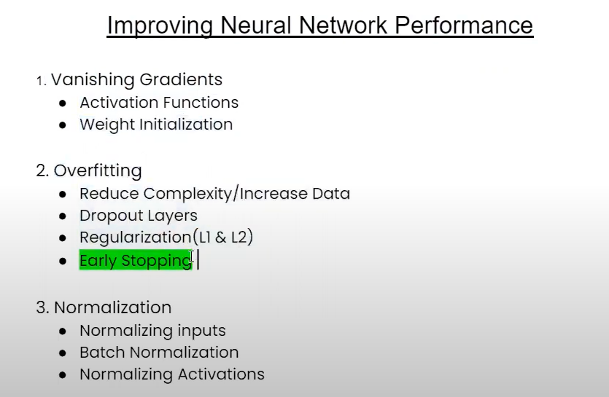
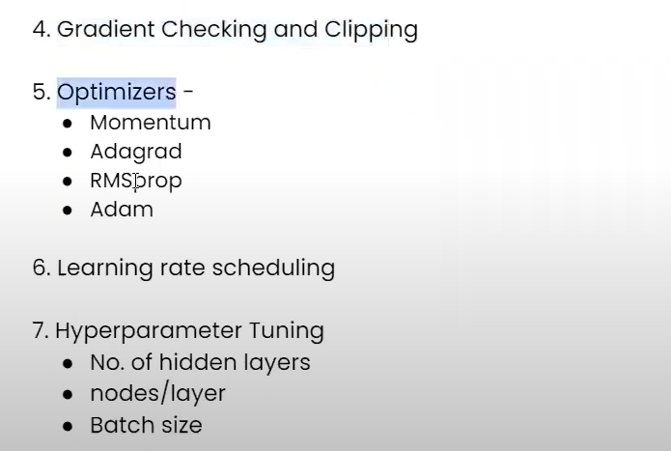

Dropout Layer in Deep Learning | Dropouts in ANN | End to End Deep Learning
https://www.youtube.com/watch?v=gyTlcHVeBjM&list=PLKnIA16_RmvYuZauWaPlRTC54KxSNLtNn&index=24&pp=iAQB

Dropouts original paper - https://jmlr.org/papers/volume15/sriv...
Dropout Layers in ANN | Code Example | Regression | Classification
https://www.youtube.com/watch?v=tgIx04ML7-Y&list=PLKnIA16_RmvYuZauWaPlRTC54KxSNLtNn&index=25&pp=iAQB

Classification Code - https://colab.research.google.com/dri...
Regression Code - https://drive.google.com/file/d/1p9I7...
Paper link - https://jmlr.org/papers/volume15/sriv...
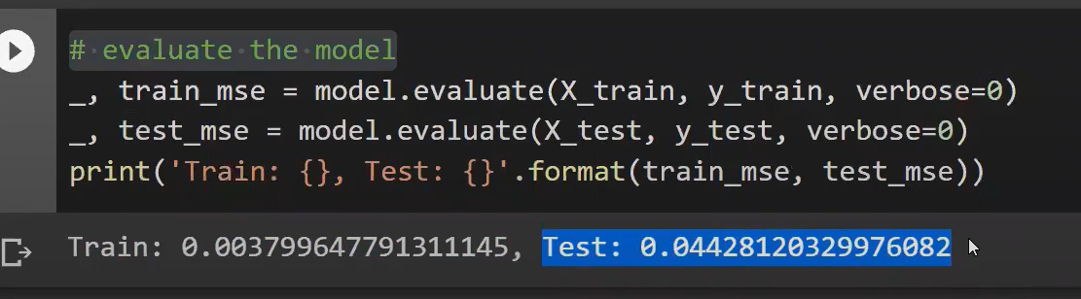
Training accuracy is 1/10 of test. This is overfitting. So, apply dropout and check accuracy.
Regularization in Deep Learning | L2 Regularization in ANN | L1 Regularization | Weight Decay in ANN
https://www.youtube.com/watch?v=4xRonrhtkzc&list=PLKnIA16_RmvYuZauWaPlRTC54KxSNLtNn&index=26&pp=iAQB

Code - https://colab.research.google.com/dri...

Activation Functions in Deep Learning | Sigmoid, Tanh and Relu Activation Function
https://www.youtube.com/watch?v=7LcUkgzx3AY&list=PLKnIA16_RmvYuZauWaPlRTC54KxSNLtNn&index=27&pp=iAQB

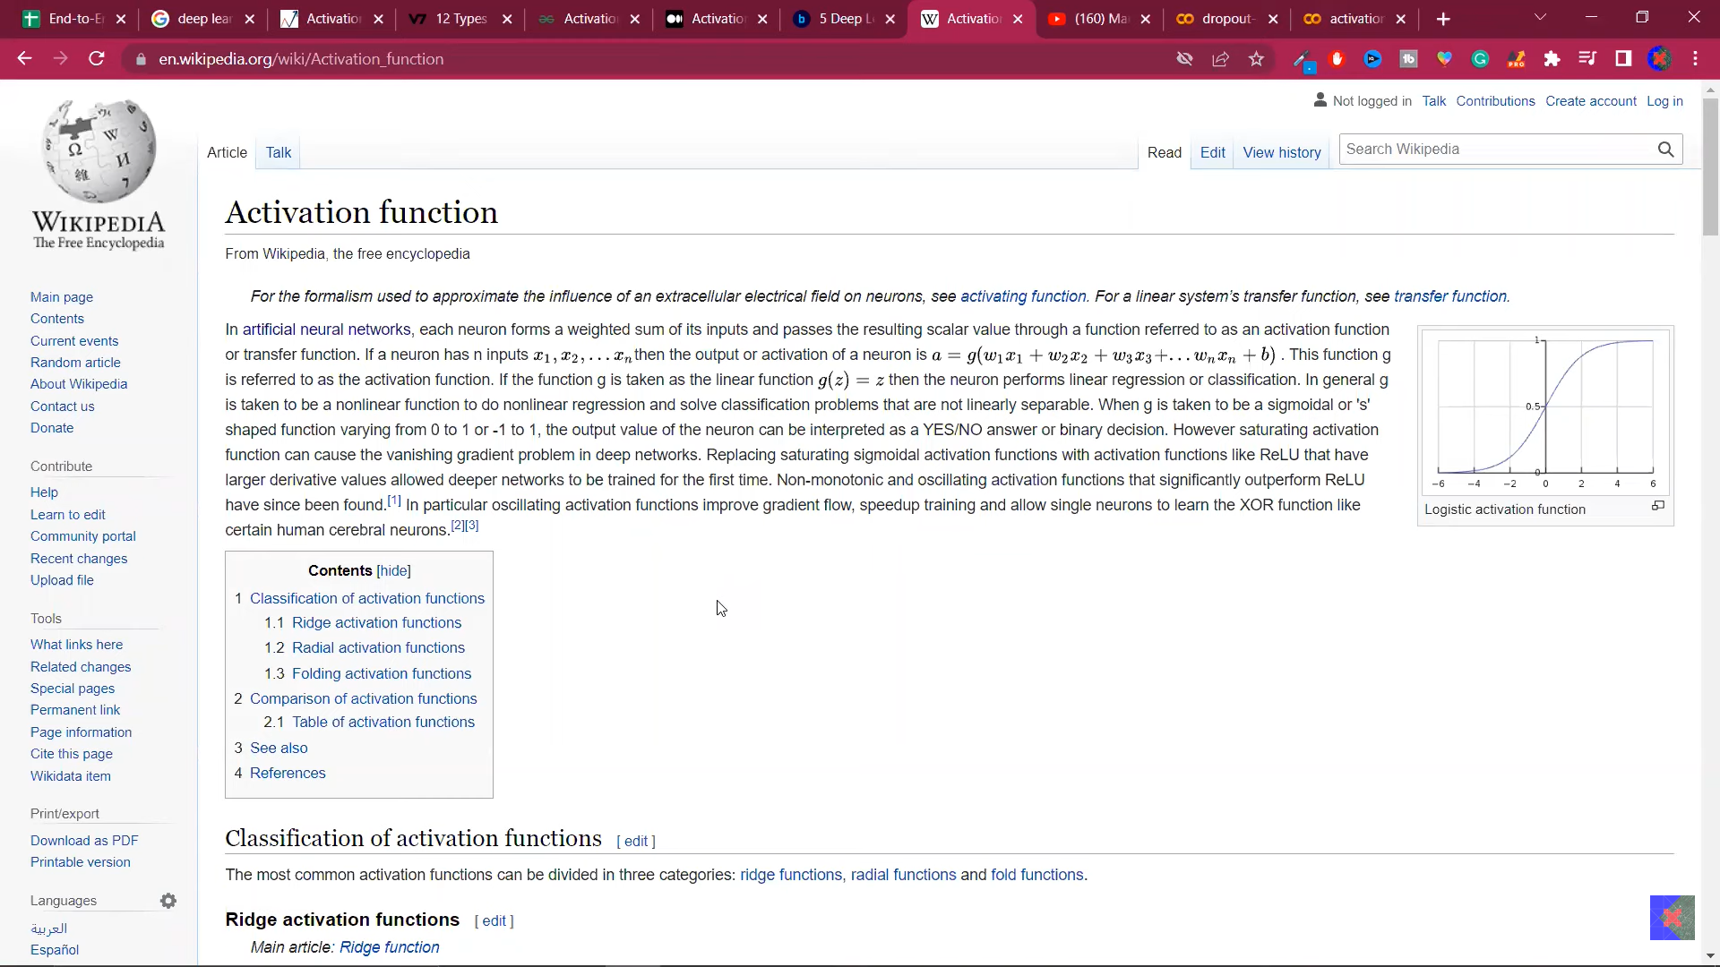
Relu Variants Explained | Leaky Relu | Parametric Relu | Elu | Selu | Activation Functions Part 2
https://www.youtube.com/watch?v=2OwWs7Hzr9g&list=PLKnIA16_RmvYuZauWaPlRTC54KxSNLtNn&index=28&pp=iAQB

Weight Initialization Techniques | What not to do? | Deep Learning
https://www.youtube.com/watch?v=2MSY0HwH5Ss&list=PLKnIA16_RmvYuZauWaPlRTC54KxSNLtNn&index=29&pp=iAQB

🧑‍💻Code: https://colab.research.google.com/dri...
https://colab.research.google.com/dri...
Viz Tool: https://www.deeplearning.ai/ai-notes/...
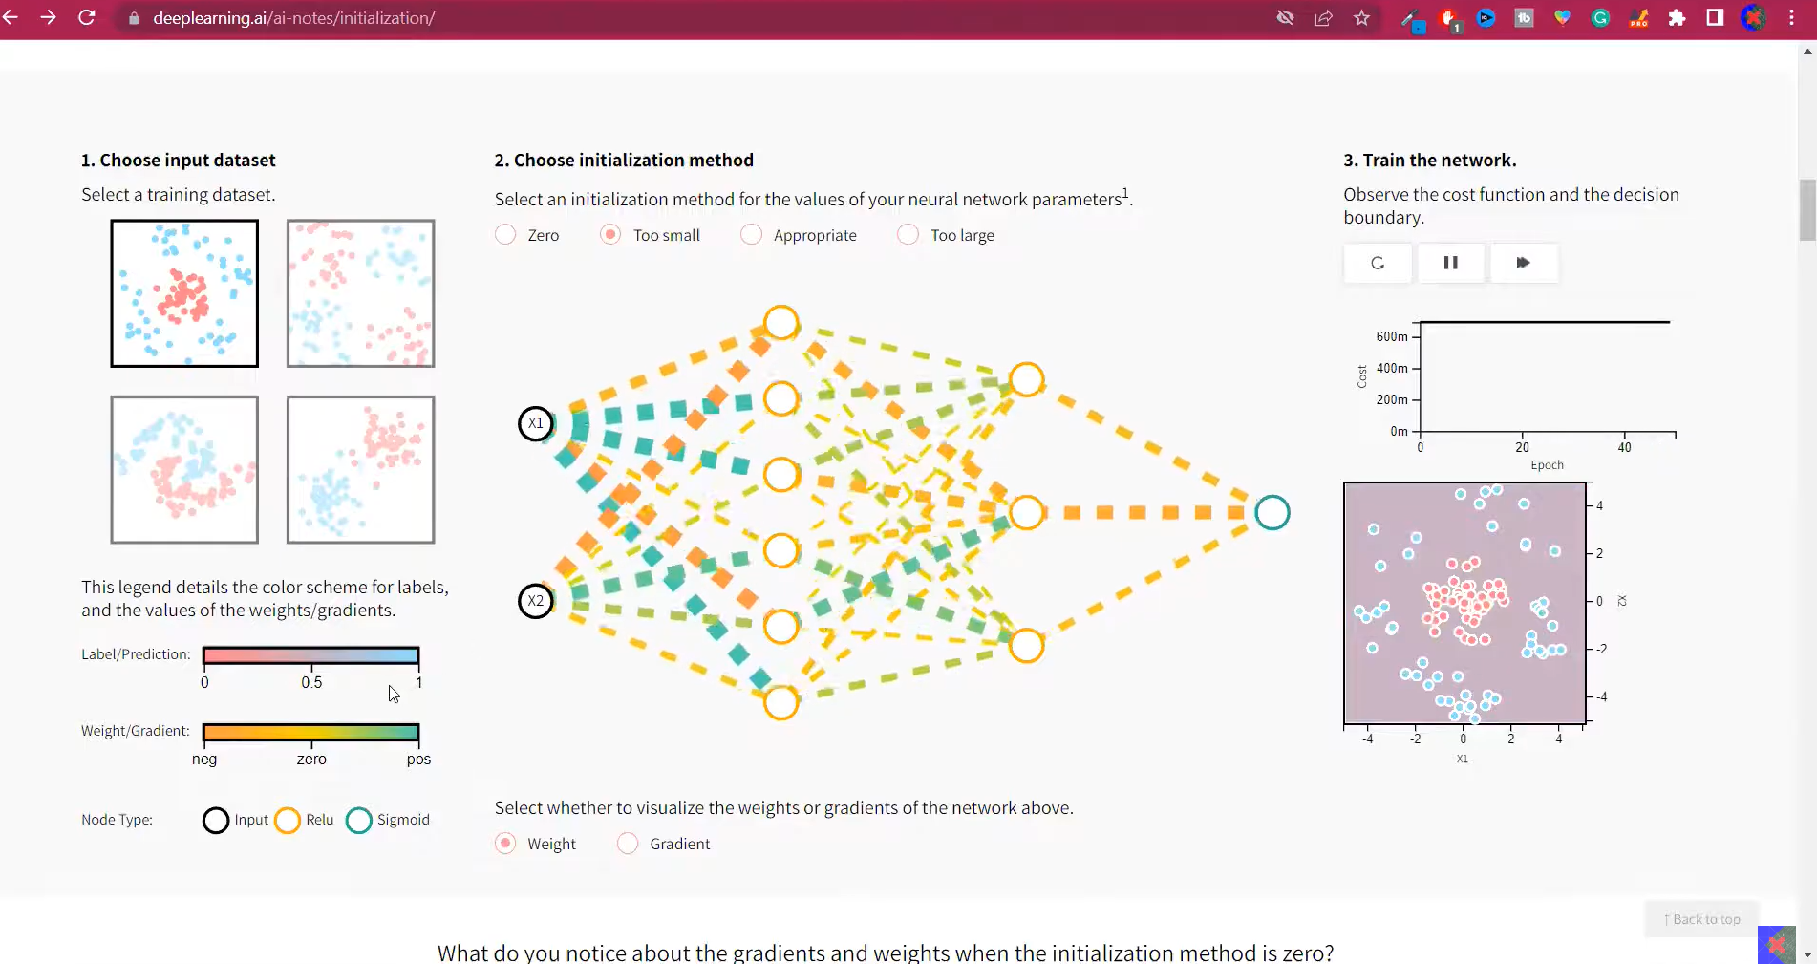
Relu me training slow hoga, but vanishing gradient problem nhi hoga.
Xavier/Glorat And He Weight Initialization in Deep Learning
https://www.youtube.com/watch?v=nwVOSgcrbQI&list=PLKnIA16_RmvYuZauWaPlRTC54KxSNLtNn&index=30&pp=iAQB

The following pointers would be discussed:
1. Weight initialization techniques in neural networks
2. Xavier initialization in neural network
3. He initialization in neural network
Digital Notes for Deep Learning: https://shorturl.at/NGtXg
🧑‍💻Code: https://colab.research.google.com/dri...
Batch Normalization in Deep Learning | Batch Learning in Keras
https://www.youtube.com/watch?v=2AscwXePInA&list=PLKnIA16_RmvYuZauWaPlRTC54KxSNLtNn&index=31&pp=iAQB

Code - https://colab.research.google.com/dri...
Optimizers in Deep Learning | Part 1 | Complete Deep Learning Course
https://www.youtube.com/watch?v=iCTTnQJn50E&list=PLKnIA16_RmvYuZauWaPlRTC54KxSNLtNn&index=32&pp=iAQB

Exponentially Weighted Moving Average or Exponential Weighted Average | Deep Learning
https://www.youtube.com/watch?v=jAqVuYJ8TP8&list=PLKnIA16_RmvYuZauWaPlRTC54KxSNLtNn&index=33&pp=iAQB

SGD with Momentum Explained in Detail with Animations | Optimizers in Deep Learning Part 2
https://www.youtube.com/watch?v=vVS4csXRlcQ&list=PLKnIA16_RmvYuZauWaPlRTC54KxSNLtNn&index=34&pp=iAQB

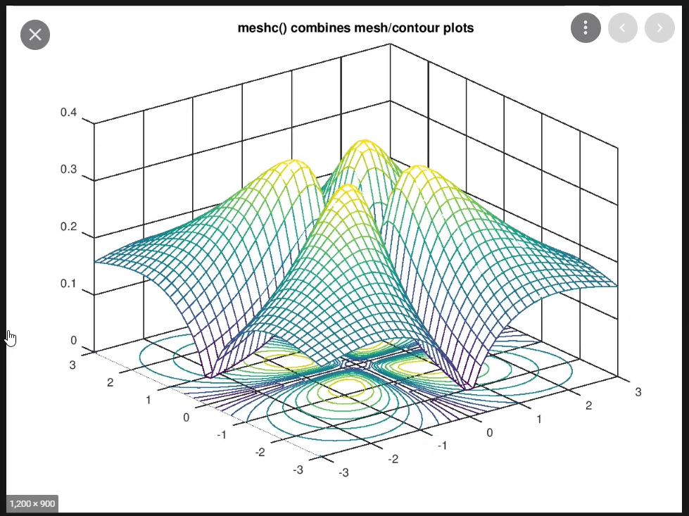
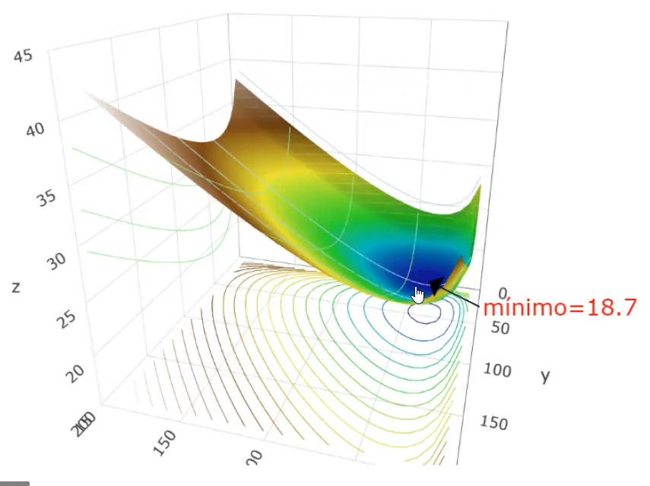
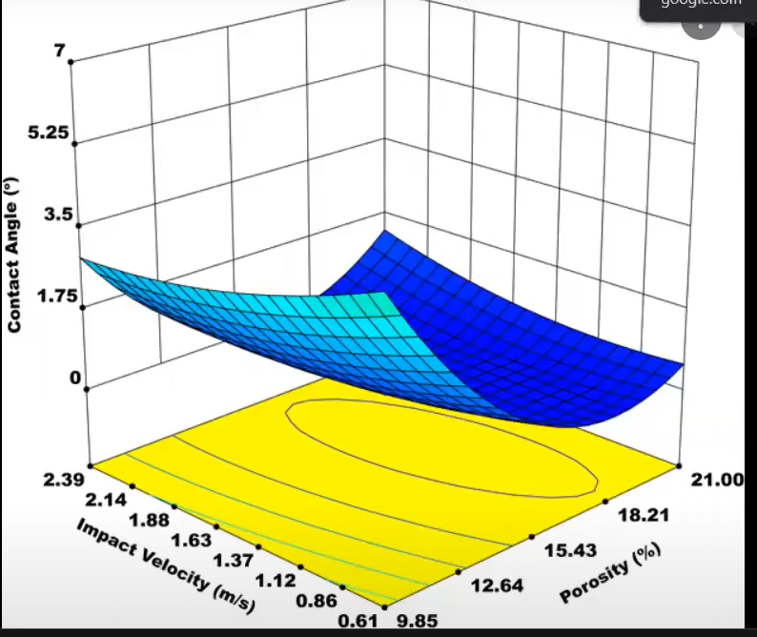
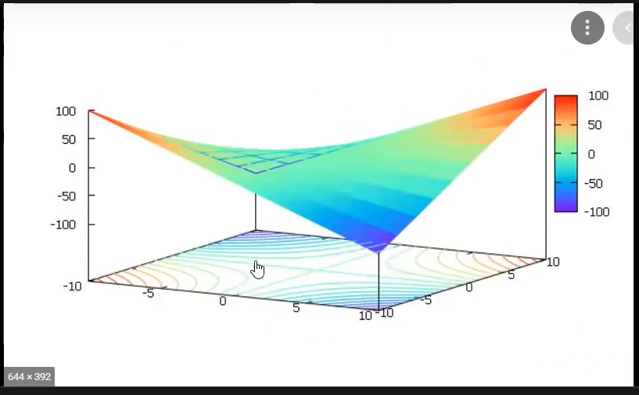
Jha pe flat hai wha pe cocentix circle dur dur honge.
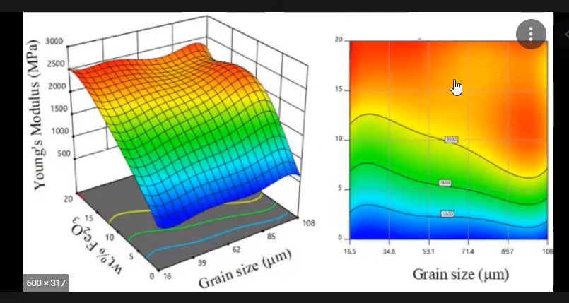
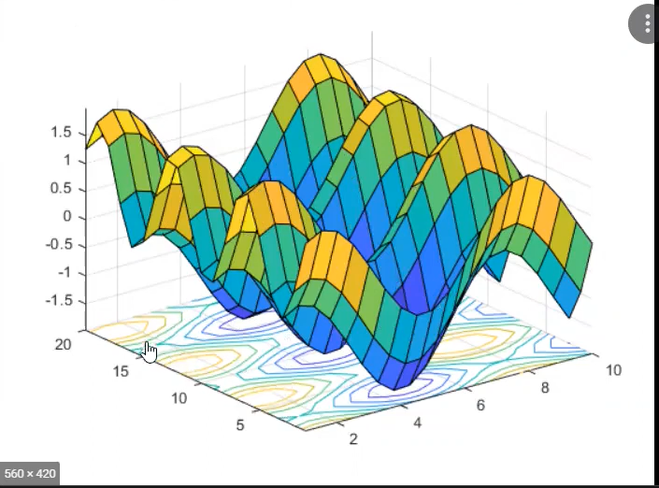
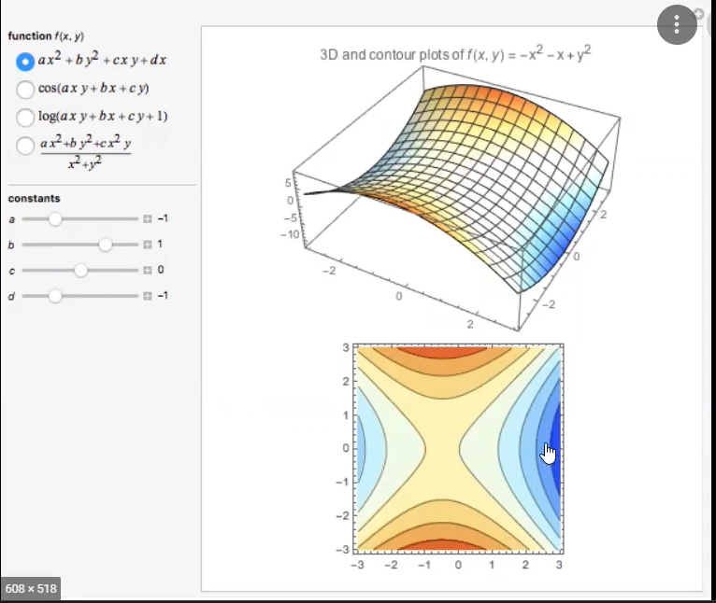
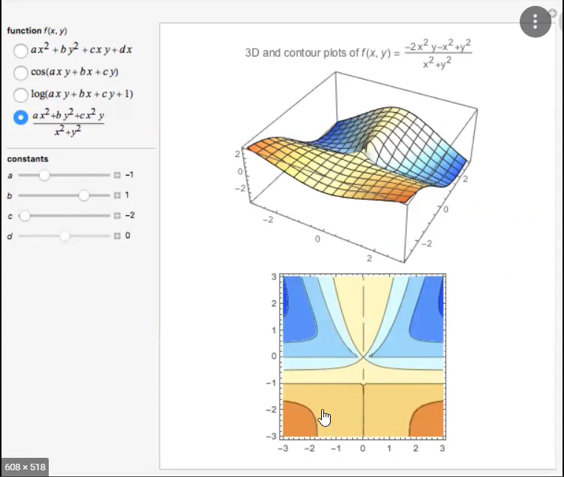
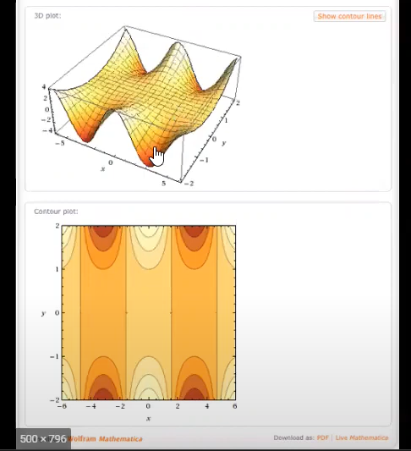
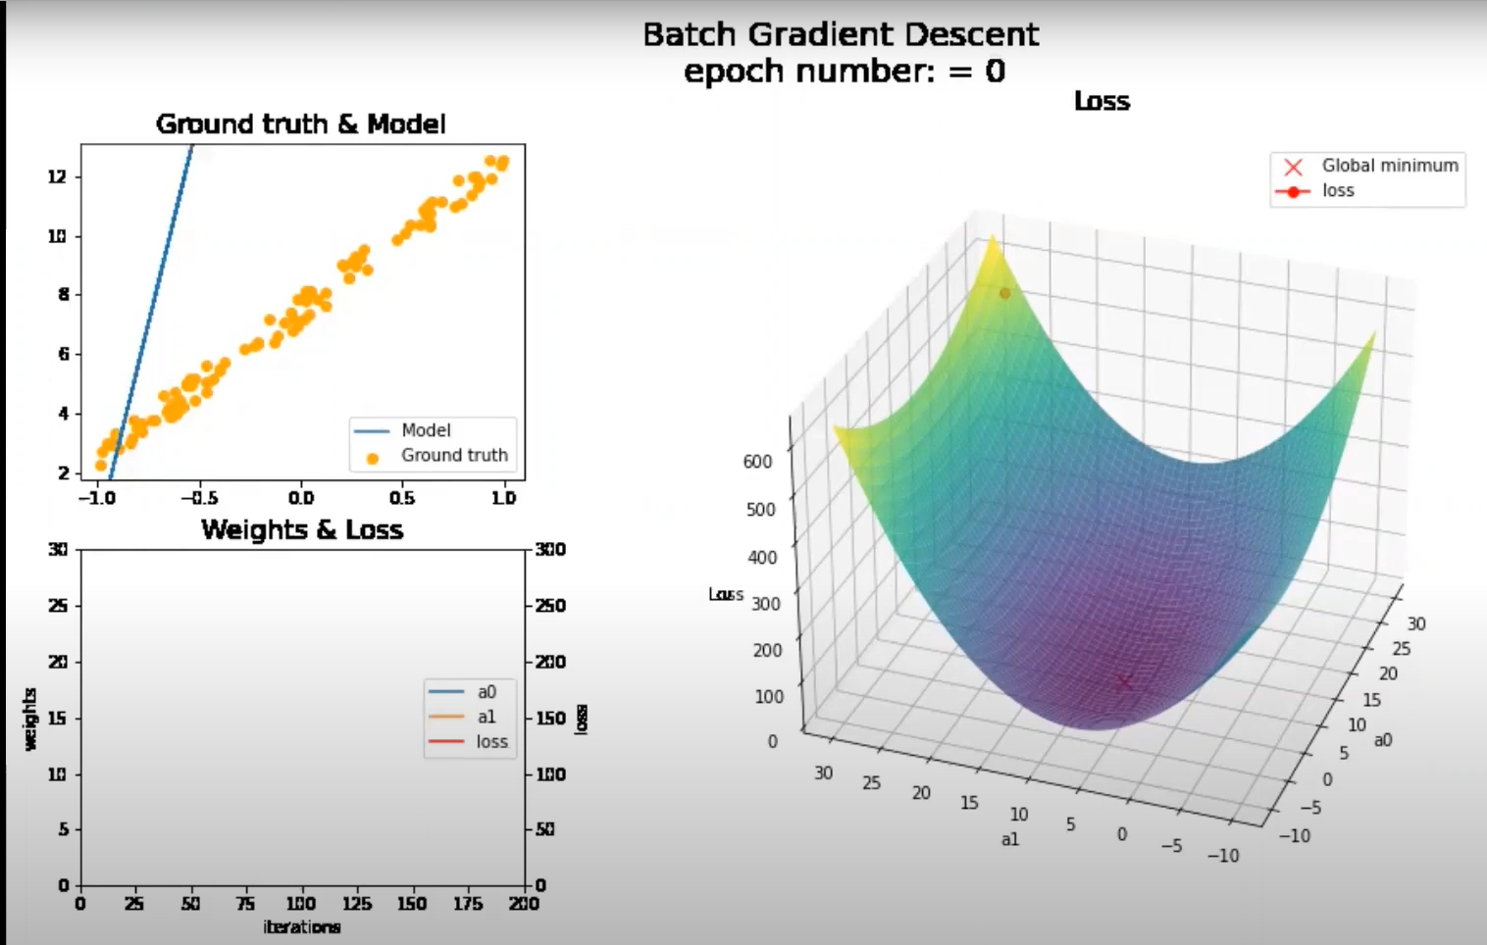
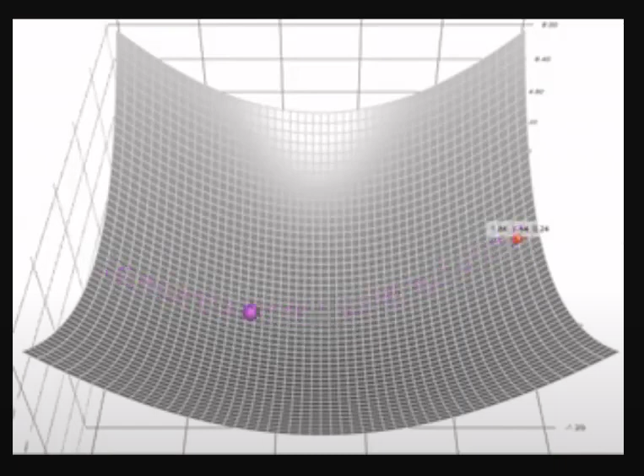
When Beta=1 , then there will be no decay.
Ball error surface pe ghumte reh jaayegi without friction.
This is dynamic equilibrium.
0 value pe SGD ban jaayega.
1 me decay nhi hoga. Dynamic equilibrium me fas jaayaga
Beta value 0.5-0.9 is best.
